Church News
My Church
New or newish to SWEC?
Pastor Pete and Karen would like to invite you to come over for supper at their house over two Tuesday evenings in May (1st and 8th at 8pm). This will be an excellent way to find out more about SWEC and how you can make this church your church. Free! To RSVP, contact them at pko@swec.org.au

Support Gospel work at SWEC!
Generous financial partners are needed to help grow the ministry of Gospel work at SWEC.
Please consider partnering with SWEC by setting up electronic giving.
For information on how to set this up, email give@swec.org.au

Community Groups
Want to know how your faith in Jesus interacts with your everyday life? Community groups are a great place to help you think through this. Meeting throughout the week on a regular basis, community groups are a great opportunity to help make sense of what it means to be a believer of Jesus in this world. For more information please email communitygroups@swec.org.au

Upcoming Events

May
8 - My Church - Newcomer's supper
6 – SWEC AGM (1-3pm, Kingsgrove)
19 - EQUIP women's conference (at venue - no live stream)

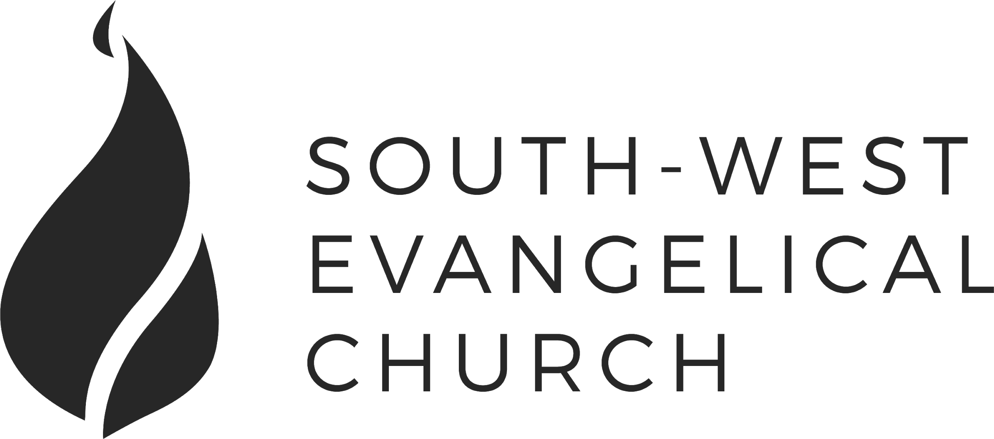

Sunday, 6 May 2018 | Bankstown | www.swec.org.au
Pastor Dom Cheung | 0466 110 456 | dcheung@swec.org.au

What we’ll be doing during our time together
1. Worship
We’ll be worshipping God through song, prayer and by hearing His word.
Today’s confession prayer
Almighty and most merciful Father,
You have loved us with an everlasting love,
But we have gone our own way
And have rejected you in thought, word, and deed.
We are sorry for our sins
And turn away from them
For the sake of your Son who died for us,
Forgive us, cleanse us and change us.
By your Holy Spirit, enable us to live for you,
And to please you more and more;
Through Jesus Christ our Lord.
Amen.
2. Community
An opportunity to get updated with what’s happening at SWEC!
3. Prayer
We’ll be praying for various needs in our church, the wider community, and the world.
4. God’s Word
Today’s sermon will be from and will be given by Peter Ko.
5. Response
An opportunity for us to respond by singing, through holy communion, and by financial giving.
6. Blessing & Sending
Go with God’s blessing to love and serve him and the world.

Pastors  Peter Ko (Lead Pastor)  Allan Mao  Stephen Fei  Dom Cheung  Karen Ko | Elders  Andrew Lim  Kirby Wong  Nelson Siu  board@swec.org.au | Student Pastors  Andrew Hayes  James Hoey  Ministry Intern  Lisa Truong

Road-Tripping With God

Numbers 1-10

1. The Story So Far

2. Final Preparations
a. The Passover

b. Cloud and Fire

c. Good and Holy God, Obedient People

3. What Not To Forget
a. We’re on a journey

b. God is holy and so are we

c. God is guiding us

d. The cross of Jesus



